**DAILY ONLINE ACTIVITIES SUMMARY**

|  |  |  |  |  |  |  |  |  |
| --- | --- | --- | --- | --- | --- | --- | --- | --- |
| **Date:** | **08/07/2020** | | | | | **Name:** | **VIRESH** | |
| **Sem & Sec** | **4th SEM & ‘B’ SEC.** | | | | | **USN:** | **4AL18CS097** | |
| **Online Test Summary** | | | | | | | | |
| **Subject** | | **Design and Analysis of Algorithms** | | | | | | |
| **Max. Marks** | | **-** | | **Score** | | | **-** | |
| **Certification Course Summary** | | | | | | | | |
| **Course** | **Introduction to Cyber Security** | | | | | | | |
| **Certificate Provider** | | | **Greatlearning Academy** | | **Duration** | | | **7.0 Hrs.** |
| **Coding Challenges** | | | | | | | | |
| **Problem Statement 1:** Write a java program to find whether the given strings are  anagram. | | | | | | | | |
| **Status: Executed.** | | | | | | | | |
| **Uploaded the report in Github** | | | | | **Yes** | | | |
| **If yes Repository name** | | | | | **Lockdown-Coding**  <https://github.com/viresh-kulal/Lockdown-Coding>  <https://github.com/alvas-education-foundation/Viresh/tree/master/coding_solutions> | | | |
| **Uploaded the report in slack** | | | | | **Yes** | | | |

**Online Test Summary:** **Today 18CS42 Descriptive test was conducted there were three questions the test was from 10:15am to 11:00am. Scores not received.**

**Online Certification Course Summary: Today I had gone through Cryptography concept which is an important technique to secure our information when we deal with network security. Also I have learnt about its major 2 types in detail with the explained examples. Also I came to know that Public key cryptography plays an important role to securing the data in our daily life.**

**The snapshots of today’s session is attached below.**

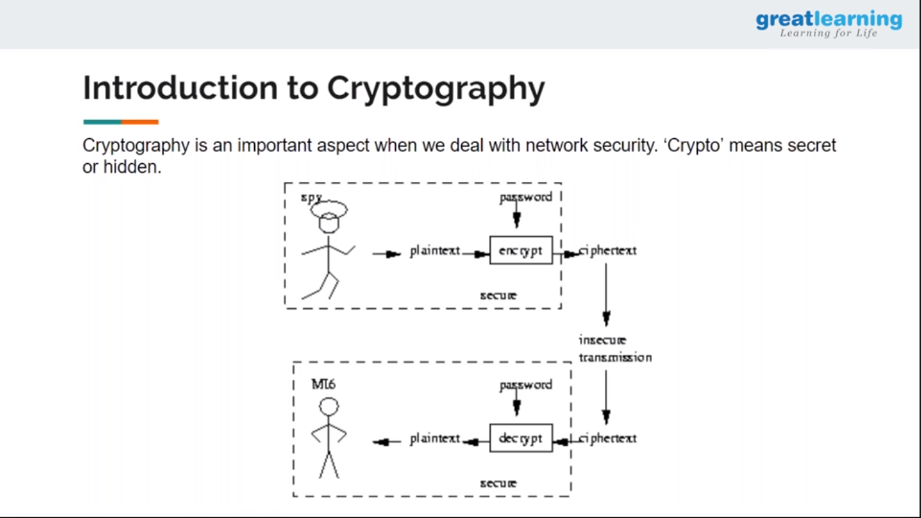 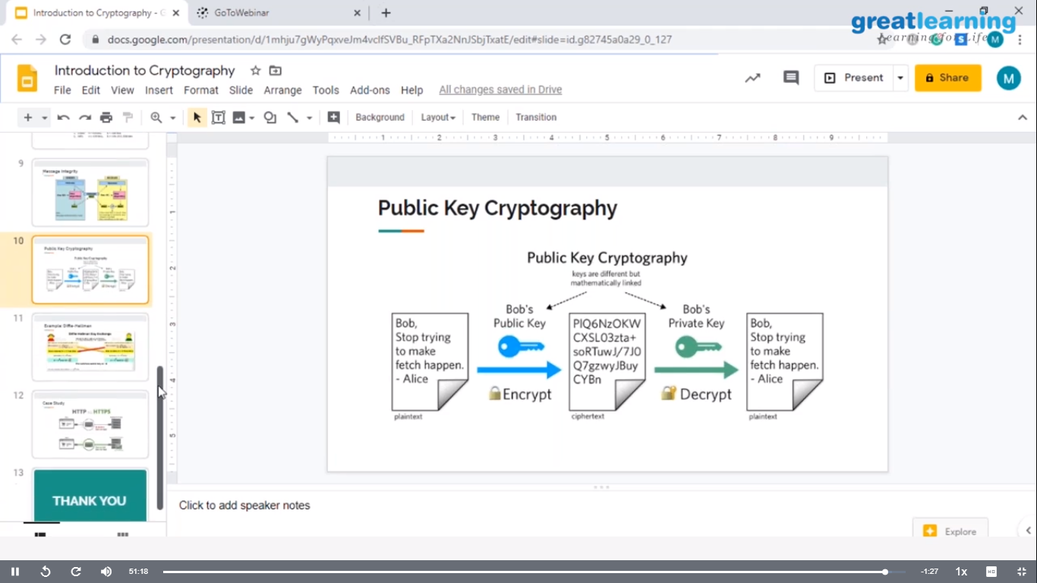

**Online Coding Summary: Today I had received one program from prof. Shilpa CSE Dept. The program is mentioned above(pg.01). I have also uploaded it to my Github repository.**

The Repository link is: <https://github.com/viresh-kulal/Lockdown-Coding>

<https://github.com/alvas-education-foundation/Viresh/tree/master/coding_solutions>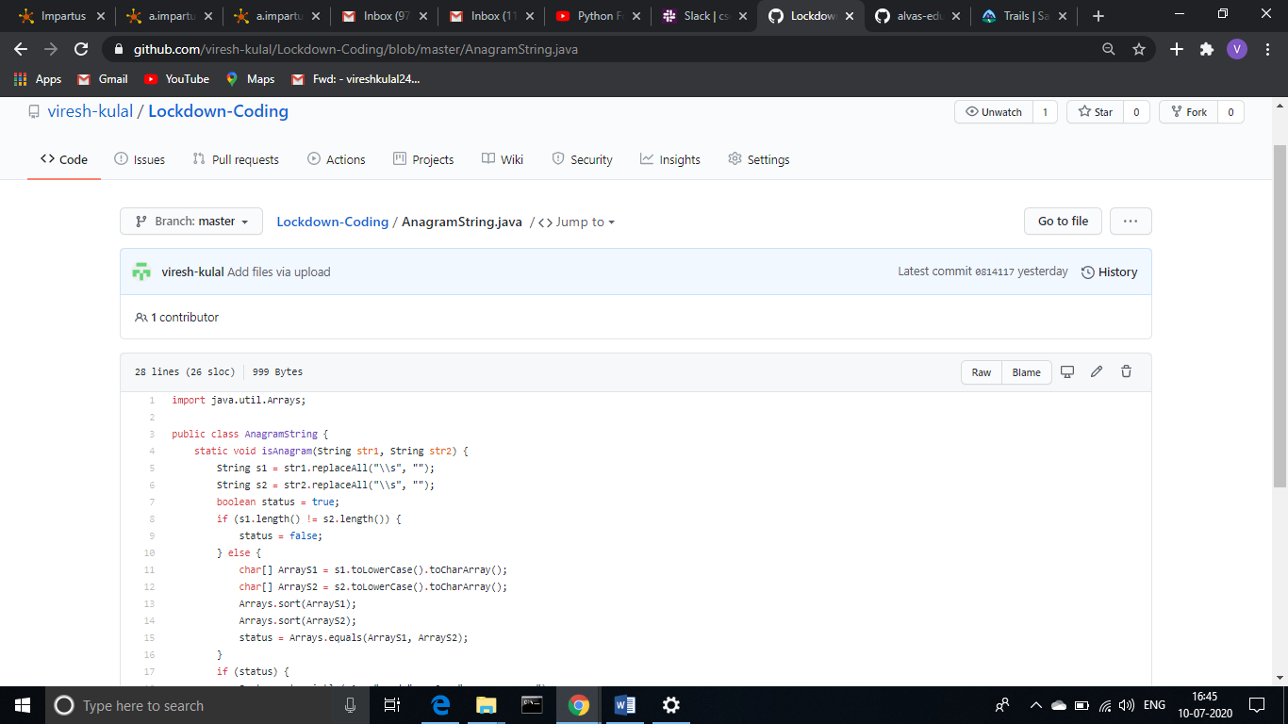

**This is the Snapshot of my Github repository were I have uploaded the code. File name is AnagramString.java**

**Thank you.**